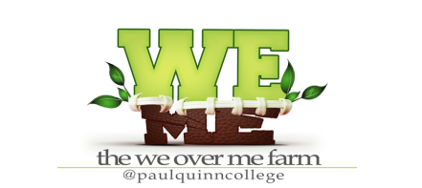
WAIVER OF LIABILITY FOR VOLUNTEERS
Volunteer’s Name: ____________________________________________________
To help protect the WE over ME Farm at Paul Quinn College’s volunteers and to minimize liability to the Farm itself, please read the following conditions that apply to your service as a volunteer.
- I wish to volunteer my time, effort, and services as a volunteer to assist the WE over ME farm at Paul Quinn College.
- As a volunteer, I donate my time, effort, and services to the Farm and understand that I will receive no compensation in return.
- I recognize and understand that my volunteer activities for the Farm expose me to the possibility of injury to my person and property and that I may suffer some kind of injury as a result of an accident and other unforeseen circumstances.
- I recognize that as a volunteer, I am not covered by any workers compensation or similar insurance that would pay my medical bills incurred because of any injury I may receive while performing services as volunteer.
- Despite this risk of injury and lack of workers compensation or other medical insurance coverage from the Farm, I knowingly and voluntarily waive any and all claims, actions, or causes of action against the WE over ME Farm at Paul Quinn College and agree to hold the WE over ME Farm at Paul Quinn College, its trustees, agents, affiliates, and employees harmless for any injury or damage that I may suffer as a result of my activities as a volunteer for the Farm.
- In return for my agreement to these conditions, WE over ME Farm at Paul Quinn College agrees to accept my services as a volunteer.

Signature of Volunteer:_____________________________
(Parent/ Guardian if under the age of 18)

