PHPC Serves
July 28-29, 2017
We Over Me Farm
When: Saturday, July 29th
9:00 am - 11:00 am
Where: Paul Quinn College
3837 Simpson Stuart Road
Dallas, TX 75241

Volunteers will help with farm chores and activities from 9AM-11AM. Please wear closed-toed shoes, weather appropriate clothing, including clothes you don't mind potentially getting dirty. The farm will provide gloves, water, and any tools needed for our projects. We will meet everyone at the farm. All ages are welcome!

About the farm:
Located in a federally-recognized food desert, the Farm at Paul Quinn College (formerly a football field) has produced and provided more than 30,000 pounds of organic produce since its inception in March 2010, and no less than 10% of this produce has been donated to neighborhood charitable organizations. The rest supports community members, the College, and restaurants and grocers throughout Dallas.
In addition to providing fresh, healthy, affordable food options for its surrounding residents, the Farm strives to improve communities throughout the metroplex by providing hands-on educational experiences for youth and adults alike to promote healthy eating, improved food access, and environmental stewardship.
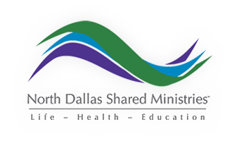
--
North Dallas Shared Ministries
When: Friday, July 28th
9:00 am- noon
Where: 2875 Merrell Road
Dallas, TX 75229

NDSM strives to deliver aid as efficiently and effectively as possible to those in our community. NDSM offers a wide variety of assistance programs including (but not limited to) a medical clinic, job counseling, a dental clinic, food stamp and Medicaid application assistance, and a food pantry.

Volunteers will be helping with the food pantry and in the clothes closet.

Austin Street Center
When: Saturday, July 29
9:00 am- noon
Where: 2929 Hickory Street
Dallas, 75226
For over 30 years, Austin Street Center has specialized in caring for the most vulnerable homeless men and women in Dallas. Beyond meeting basic needs, Austin Street is committed to individualized care for each person who comes in for help.
Volunteers will be cleaning the guests’ cots at Austin Street. The cleaning will be done outside of the shelter. Therefore, shorts and t-shirts with tennis shoes are recommended.
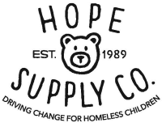
--
Hope Supply Co.
When: Saturday, July 29th
9:00 am – 11:00 am
Where: 10480 Shady Trail
Suite 104
Dallas, TX 75220

The mission of Hope Supply Co. is to meet the critical needs of homeless children across North Texas by providing necessities including diapers, clothing, school supplies, toys and programs to enhance their lives.

Volunteers 10 years and older

Suggestion to volunteers: since volunteers work in an un air-conditioned warehouse, please dress accordingly

